***The pie charts compare ways of accessing the news in Canada and Australia.***

***Summarise the information by selecting and reporting the main features, and make comparisons where relevant.***

Write at least 150 words.

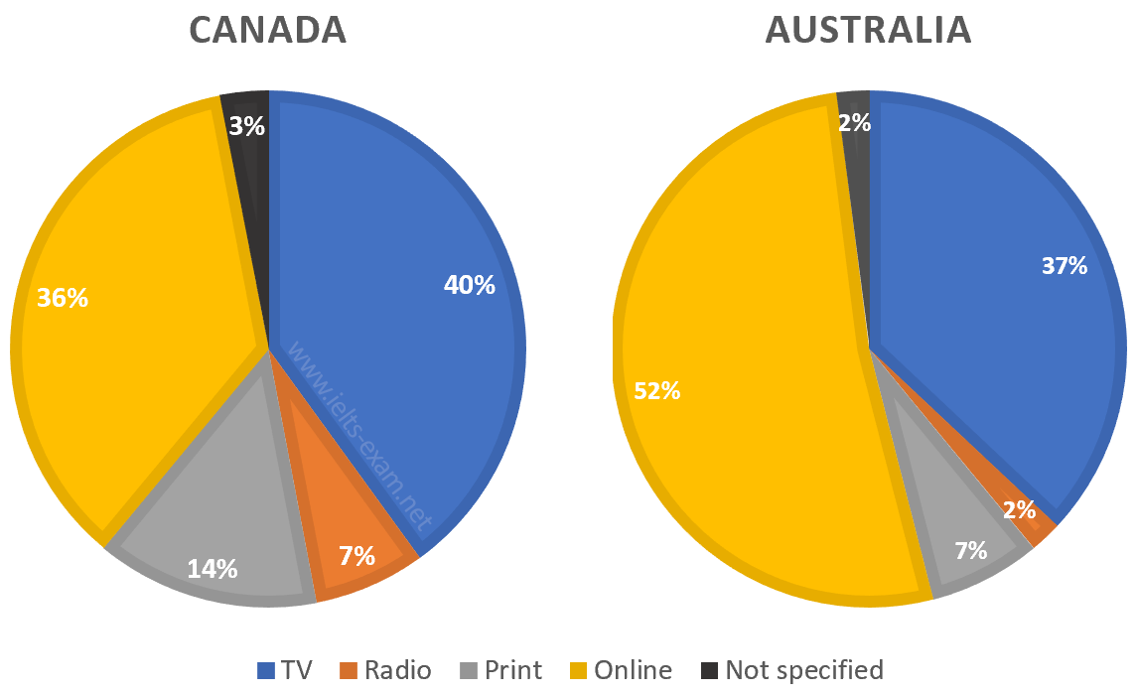

### **Model answer**

The pie charts show the principle ways of finding out the news in two different countries, Canada and Australia. The two nations show broadly similar patterns, though there are some differences, both significant and minor.

One of the most prominent features of this data is that, while in Canada over a third of people access the news online, in Australia the figure is more than half, at 52%. It is apparent that viewing the TV news is popular in both countries, with about two fifths of Canadian population favouring this mode of delivery and only 3% fewer in Australia. One major difference between Canada and Australia is that over twice as many people read the news in print in the former, compared with the latter. The figures are 14% and 7% respectively. ***Similarly, listening to the news on the radio is preferred by three times more people in Canada than in Australia.***

Overall, it can be said that the high levels of internet use in Australia mean that other methods such as radio and print are used less in comparison with Canada.

(182 words)

***Investment in local amenities such as leisure centres is the best way for the government to foster a good community spirit.***

***To what extent do you agree or disagree?***

***What other measures do you think might be effective?***

Give reasons for your answer and include any relevant examples from your own knowledge or experience.

Write at least 250 words.

### **Model answer**

A good community spirit can certainly be promoted by various means, including investment in local amenities such as leisure complexes. While I agree that this approach is worthwhile, it is not necessarily the best, as there are other equally important strategies.

Local amenities like leisure complexes are important for bringing people of all ages together and for providing them with opportunities to mingle with friends and meet new people. As well as facilities, such centres can provide a wide range of activities like swimming clubs and yoga classes as well as art classes, which give people the chance to meet old and new friends and strengthen the local community spirit.

Other amenities such as libraries that are open to the public can also play a role in developing a community. Other measures that are also useful are holding local festivals and fun days, not just in parks but in streets that are closed off to traffic for the day or weekend. In fact, any activity that involves local people coming together, such as volunteering in the clean-up of local neighbourhoods or tidying up local spaces, is worthwhile.

Another important strategy is the design of local neighbourhoods. Unfortunately, the enormous pressure to increase accommodation for growing populations means that there is less space for houses with gardens. However, it is possible to provide well-maintained open spaces that attract local people along with venues to give them a chance to interact with each other, like local shops instead of large supermarkets, all of which can nurture a local identity and spirit.

In conclusion, investing in local amenities is one among many approaches that can contribute to the fostering of a good spirit within communities.

(282 words)